St Margaret Clitherow Catholic Primary School Newsletter

Welcome Back!
We are delighted to have welcomed all of our children back after the summer break. It has been a fantastic start to the new academic year, with children settling confidently into their new classes.
You can find updates about your child’s class on the school website under the ‘Classes’ section. The school calendar is also up to date with important upcoming events — please take a moment to review it regularly.

School Lunches – Important Reminder
Please note that school staff are no longer able to order lunches on behalf of children.
It is crucial that parents and carers order their child’s lunches in advance via the appropriate system to ensure that your child receives a meal they will enjoy.
Ordering in advance helps us:
• Ensure every child gets a meal they will eat
• Minimise food waste
• Support the kitchen team with accurate planning
If you are having any difficulty with the ordering system or need assistance, please contact the school office as soon as possible.

Reporting Absence – Please Call Before 9:00am
If your child is unwell and unable to attend school, please ensure you contact the school office as early as possible — ideally before 9:00am.
This helps us avoid the need to follow up with families during busy office hours and ensures that your child’s absence is recorded correctly.
There is an answerphone service available outside of office hours, so you can leave a message at any time.
📞 01803 851647
Please include your child’s name, class, and the reason for their absence in your message.
Thank you for your cooperation in helping us manage attendance efficiently and sensitively, and for allowing the school office to run smoothly.

Attendance Matters
At St Margaret Clitherow Catholic Primary School, we believe that every day counts. Good attendance is directly linked to children’s progress, wellbeing, and long-term success.
Attendance Expectations:
• All children are expected to attend school every day unless they are genuinely unwell.
• The national attendance target is 96% or above – we encourage all families to aim for this.
• Punctuality is also vital. The school day starts promptly with registers closing at 9:00am.
Did You Know?
• 95% attendance = 10 days of learning missed per year
• 90% attendance = 4 weeks missed — that’s nearly half a term
• Being just 5 minutes late every day adds up to 3 full days of lost learning in a school year
Holidays During Term Time:
Holidays during term time will not be authorised unless there are exceptional circumstances. Unauthorised absences may result in a penalty notice.
Help Us Support Good Attendance:
• Let us know before 9:00am if your child is absent due to illness
• Try to book medical appointments outside school hours
• Talk to us if you’re facing any barriers to regular attendance — we’re here to help
Together, we can ensure that all our children make the most of their learning opportunities.

Proud of Our Sharks!
Some of our Sharks class had the fantastic opportunity to attend the A.I.M High Writing Workshop with author Clive Pig. The children showed great creativity and confidence in their writing — it was a wonderful experience that inspired them to keep developing their storytelling skills!
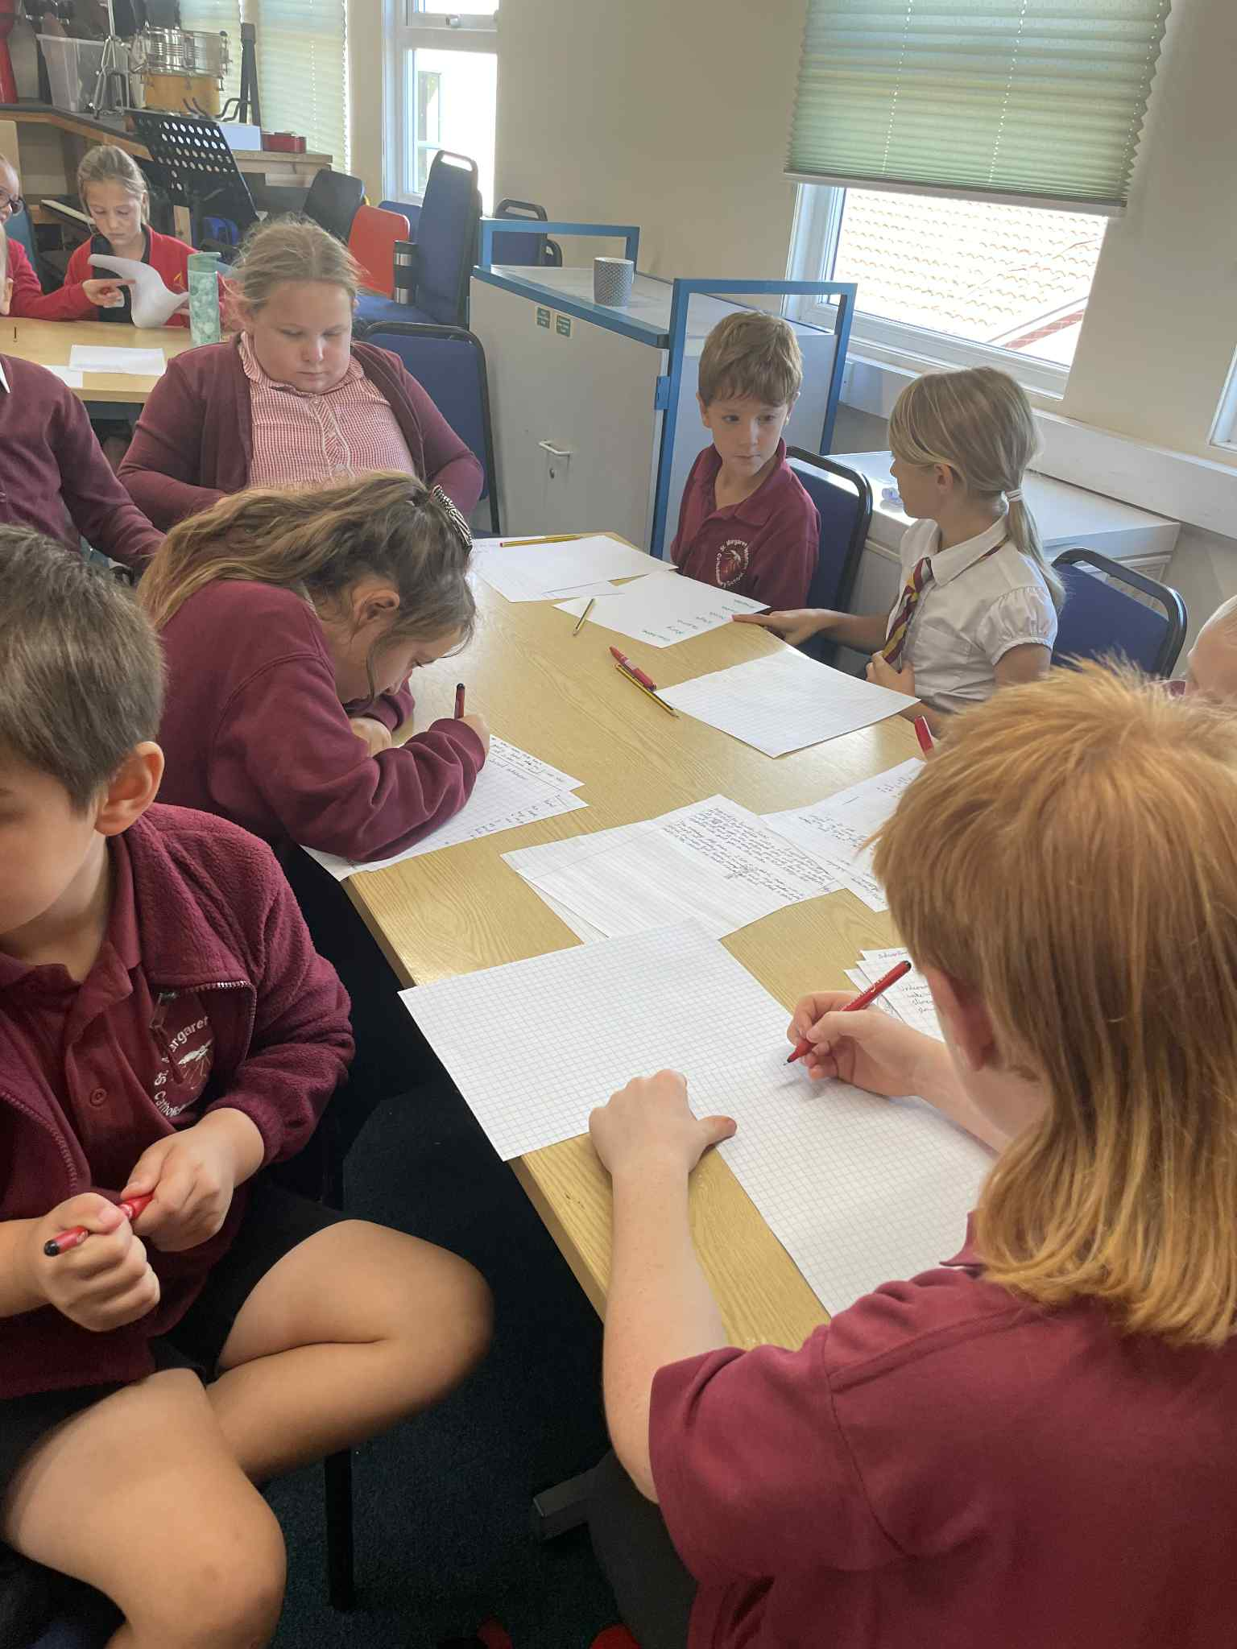

Sharks will be visiting Brixham Theatre on Monday 20th October for some behind-the-scenes insight and a hands-on workshop. Exciting!

Baton of Hope Art Workshop
This half term, some of our older children will be taking part in a special art workshop inspired by the Baton of Hope, which promotes positive mental health and emotional wellbeing.
The session will focus on the 5 Ways to Wellbeing:
• Connecting
• Being Active
• Taking Notice
• Keep Learning
• Giving
This creative opportunity will encourage pupils to explore these important themes through art, reflection, and collaboration.

Drama Club in Full Swing!
Rehearsals for our Harry Potter production are well underway, and the children are full of excitement and enthusiasm. It’s wonderful to see their confidence growing as they bring the magic of Hogwarts to life!

Christmas Shoe Box Appeal
We were delighted to welcome a visitor to school this week to tell us all about the Christmas Shoe Box Appeal. Children can choose to fill their own boxes or bring in an item listed on the letter you received. All donations need to be in by Wednesday 16th October. Thank you for your generosity and support in helping to make a difference to others this Christmas.

Parents’ Evening Appointments
Our Parents’ Evening will take place on Monday 14th October. Please sign up for an appointment via the link below to meet with your child’s class teacher. We look forward to sharing all the wonderful progress your children have made this term!
Starfish
https://docs.google.com/document/u/2/d/149VXSlDoimIi1TVI0OydMkxbuwNgTo2lE25EUR-niQw/mobilebasic?pli=1
Dolphins
https://docs.google.com/document/u/2/d/1NJS9MeuWTyso2eGd8xI-bhZi6UKWH8TrFuNCFgYD5FA/mobilebasic
Sharks
https://docs.google.com/document/u/2/d/1y3mLXPdb2o2WdMN-Orag1xYij9cKFNp2S6-WDmOviwg/mobilebasic

Become a School Governor at St Margaret Clitherow Catholic Primary School
We are currently looking for enthusiastic and committed individuals to join our Governing Body.
As a school governor, you will play a vital role in shaping the future of our school, supporting our leadership team, and helping ensure the best outcomes for all our children.
What does a School Governor do?
• Provides strategic guidance and oversight
• Supports and challenges the Headteacher and staff
• Helps monitor educational performance and school finances
• Upholds the school’s vision, ethos, and values
Who can become a governor?
You don’t need to be a parent or have an educational background — just a willingness to contribute your time, skills, and ideas. Training and support will be provided.
This is a fantastic opportunity to:
• Give back to the local community
• Develop new skills and experience
• Be part of a passionate, purposeful team
Interested?
To express your interest or find out more, please email admin@smcprimary.org or speak to Mrs Maskell directly — we’d love to hear from you!

Upcoming Events
• Harvest Festival – Tuesday 22nd October, 2:00pm: Parents are warmly invited to join us. We are collecting dry food donations for our community.
• Thursday 24th October – Last day of the first half term
• Sunday 3rd November – Staff Training Day (school closed to pupils)
• Monday 4th November – First day back for children
• Friday 7th November – Careers & Aspirations Event

Stay Up to Date
We will share any changes to events or important news on our private Facebook group:
Helping Hands of St Margaret Clitherow – join us to stay informed and connected with our school community.
School Captains
Our new school captains have had their first meeting with Mrs Dudman. We look forward to seeing them grow in their new leadership roles and are sure that they will represent our school as great ambassadors.
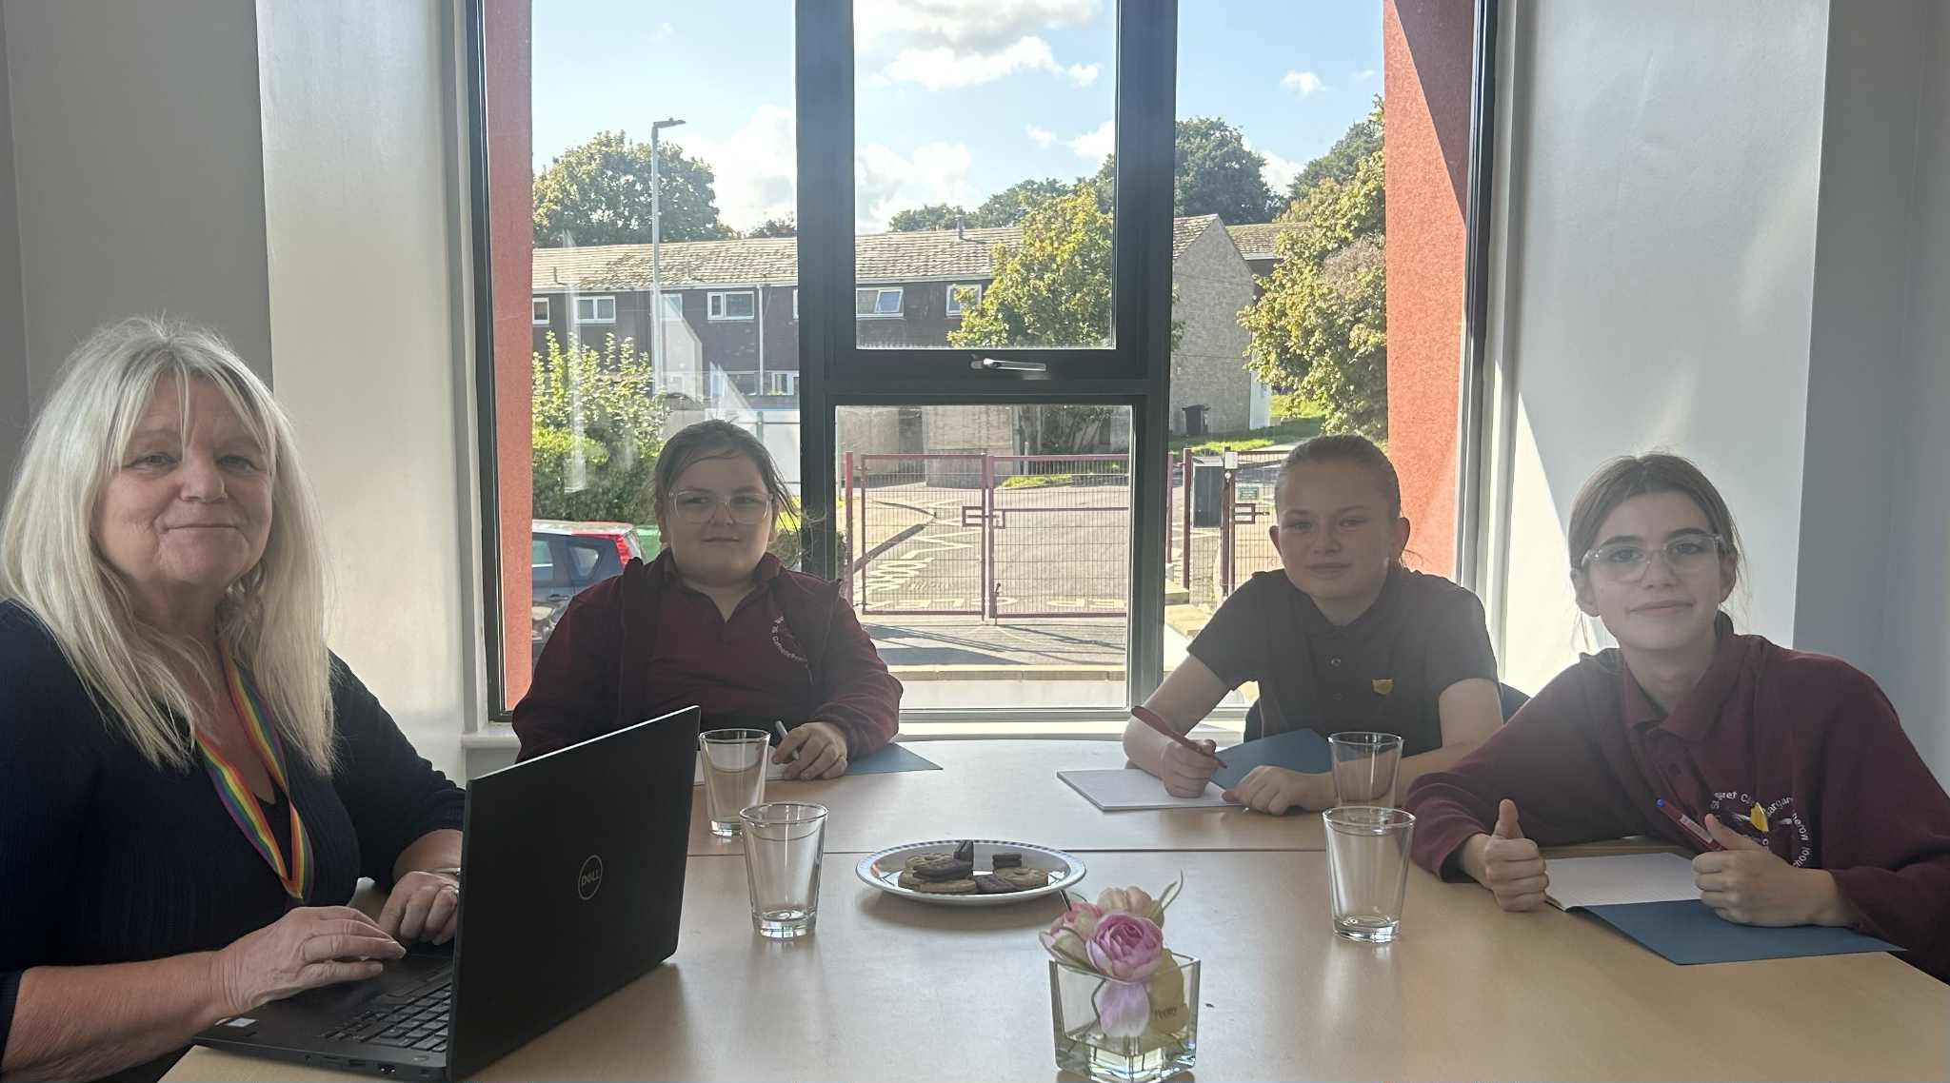

Thank you so much for your continued support.
Mrs Maskell, Mrs Dudman and the SMC Team

