

Pupil premium strategy statement
Expenditure evaluation
Strategy plan
“I was disadvantaged as a child, yet I had the advantage of being in the company of great teachers.”
(A.P.J. Abdul Khan, 11th President of India)
“Every one of our children is carrying something the world is waiting for – it’s just the world hasn’t got it yet,” Sister Judith Russi
The ‘Pupil Premium’ is a government initiative that provides extra funding aimed at pupils from disadvantaged backgrounds. Research shows that pupils from deprived backgrounds underachieve compared to their peers and that there is a strong link between eligibility for free school meals and underachievement. The Pupil Premium is designed to help each school boost the attainment of disadvantaged children and reduce the gap between the highest and the lowest achievers. The government has used pupils’ entitlement to free school meals (FSM) and children looked after by the local authority (CLA) as an indicator for deprivation. The funding is allocated according to the number of pupils on roll who have been eligible for free school meals at any point in the last 6 years (known as ‘Ever6 FSM’), an allocation for each pupil who has been ‘Looked After’ (in care) and a smaller amount for the children of service families.
Principles
- To ensure that teaching and learning opportunities meet the needs of all pupils.
- To ensure that appropriate provision is made for pupils who belong to vulnerable groups, this includes ensuring that the needs of socially disadvantaged pupils are adequately assessed and addressed.
- In making provision for socially disadvantaged pupils, we recognise that not all pupils who receive free school meals will be socially disadvantaged.
- We also recognise that not all pupils who are socially disadvantaged are registered for free school meals. We reserve the right to allocate the Pupil Premium funding to support any pupil, or groups of pupils the schools have legitimately identified as being socially disadvantaged.
- Pupil Premium funding will be allocated following a needs analysis which will identify priority groups or individuals. Limited funding and resources means that not all children receiving free school meals will be in receipt of pupil premium interventions at one time.

Pupil premium strategy statement

This statement details our school’s use of pupil premium (and recovery premium for the 2022 to 2023 academic year) funding to help improve the attainment of our disadvantaged pupils.

It outlines our pupil premium strategy, how we intend to spend the funding in this academic year and the effect that last year’s spending of pupil premium had within our school.

School overview
Detail | Data
School name | St Margaret Clitherow Catholic Primary School
Number of pupils in school | 66
Proportion (%) of pupil premium eligible pupils | 32%
Academic year/years that our current pupil premium strategy plan covers (3 year plans are recommended) | 2022-2025
Date this statement was published | October 31st 2024
Date on which it will be reviewed | February 2025
Statement authorised by | Jo Flower
Pupil premium lead | Hannah Maskell
Governor / Trustee lead | Jane Young
Funding overview
Detail | Amount
Pupil premium funding allocation this academic year | £ 36,010
Recovery premium funding allocation this academic year | £ 3335
Pupil premium funding carried forward from previous years (enter £0 if not applicable) | £ 0
Total budget for this academic year  If your school is an academy in a trust that pools this funding, state the amount available to your school this academic year | £39,345

Part A: Pupil premium strategy plan

Statement of intent
You may want to include information on:
- What are your ultimate objectives for your disadvantaged pupils?
- How does your current pupil premium strategy plan work towards achieving those objectives?
- What are the key principles of your strategy plan?
At St Margaret Clitherow Catholic Primary School, we target the use of Pupil Premium Grant funding to ensure that our disadvantaged pupils receive the highest quality of education to enable them to become active, socially responsible citizens of the future. We recognise that disadvantaged children can face a wide range of barriers which may impact on their learning.
Our ultimate objectives are to:
- Remove barriers to learning created by poverty, family circumstance and background
- Narrow the attainment gaps between disadvantaged pupils and their non-disadvantaged counterparts both within school and nationally
- Ensure ALL pupils are able to read fluently and with good understanding to enable them to access the breadth of the curriculum
- Develop confidence in their ability to communicate effectively in a wide range of
- contexts
- Enable pupils to look after their social and emotional wellbeing and to develop
- resilience.
- Access a wide range of opportunities to develop their knowledge and understanding of the world
Our Context:
- Torbay is the most deprived local authority area in the South West region. Within Torbay, around one-in-three of the population live in areas in the top 20% most deprived in England.
- 32% of pupils are eligible for Pupil Premium Funding in comparison to 23% national.

Achieving our objectives:
In order to achieve our objectives and overcome identified barriers to learning we will:
- Provide all teachers with high quality CPD to ensure that pupils access effective
- quality first teaching
- Provide targeted intervention and support to quickly address identified gaps in
- learning including the use of small group work, 1:1 tuition
- Target funding to ensure that all pupils have access to trips, residentials, first
- hand learning experiences
- Provide opportunities for all pupils to participate in enrichment activities including sport and music
- Provide appropriate nurture support to enable pupils to access learning within
- and beyond the classroom.
3
This is not an exhaustive list and strategies will change and develop based on the needs of individuals.
Key Principals:
We will ensure that effective teaching, learning and assessment meets the needs of all pupils through the rigorous analysis of data. Class teachers will identify through the class pupil premium plan, specific intervention and support for individual pupils which will be reviewed at least termly. Alongside academic support, we will ensure that those pupils who have social, emotional and mental health needs will access high quality provision from appropriately trained adults.

Challenges
This details the key challenges to achievement that we have identified among our disadvantaged pupils.
Challenge number | Detail of challenge
1 | Our assessments, observations and discussions with pupils and families have identified social and emotional issues for many pupils, notably due to a lack of social interaction, enrichment opportunities during school closures and difficulties integrating back into whole class social situations. These challenges particularly affect disadvantaged pupils, including their attainment.  Teacher referrals for support have markedly increased since the pandemic. 12 pupils (8 of whom are disadvantaged) currently require additional support with social and emotional needs, with 8 (6 of whom are disadvantaged) receiving small group interventions.
2 | Our attendance data over the last 3 years indicates that attendance among disadvantaged pupils has been between 1-6 % lower than for non-disadvantaged pupils.  8% of disadvantaged pupils have been ‘persistently absent’ compared to 2% of their peers during that period. Our assessments and observations indicate that absenteeism is negatively impacting disadvantaged pupils’ progress.
3 | Assessments, observations, and discussions with pupils indicate underdeveloped oral language skills and vocabulary gaps among many disadvantaged pupils. These are evident from Reception through to KS2 and in general, are more prevalent among our disadvantaged pupils than their peers.
4 | Our assessments and observations indicate that the education and wellbeing of many of our disadvantaged pupils have been impacted by partial school closures to a greater extent than for other pupils. These findings are supported by national studies.  This has resulted in significant knowledge gaps leading to pupils falling further behind age-related expectations, especially in maths.

Intended outcomes
This explains the outcomes we are aiming for by the end of our current strategy plan, and how we will measure whether they have been achieved.
Intended outcome | Success criteria
To achieve and sustain improved wellbeing for all pupils in our school, particularly our disadvantaged pupils. | Sustained high levels of wellbeing from 2024/25 demonstrated by:  - qualitative data from student voice, student and parent surveys and teacher observations  - a significant reduction in pupil dysregulation and mental health incidents on CPOMS  - a significant increase in participation in enrichment activities, particularly among disadvantaged pupils
To achieve and sustain improved attendance for all pupils, particularly our disadvantaged pupils. | Sustained high attendance from 2024/245 demonstrated by:  - the overall absence rate for all pupils being no more than 4%, and the attendance gap between disadvantaged pupils and their non-disadvantaged peers being reduced by 5%.  The percentage of all pupils who are persistently absent being below 4% and the figure among disadvantaged pupils being no more than 2% lower than their peers.
Improved oral language skills and vocabulary among disadvantaged pupils. | Assessments and observations indicate significantly improved oral language among disadvantaged pupils. This is evident when triangulated with other sources of evidence, including engagement in lessons, book scrutiny and ongoing formative assessment.
Improved maths attainment for disadvantaged pupils at the end of KS2. | KS2 maths outcomes in 2024/2025 show that more than 70% of disadvantaged pupils met the expected standard.

Activity in this academic year
This details how we intend to spend our pupil premium (and recovery premium funding) this academic year to address the challenges listed above.

Teaching (for example, CPD, recruitment and retention)
Budgeted cost: £ 15,010
Activity | Evidence that supports this approach | Challenge number(s) addressed
Weekly coaching from EHT and EDHT to support quality first teaching in all subjects. | Supporting high quality teaching is pivotal in improving children’s outcomes. Indeed, research tells us that high quality teaching can narrow the disadvantage gap. EEF Toolkit | 1,3 and 4
Clear programme of CPD tailored to meet needs in the SIP. | High quality teaching improves pupil outcomes, and effective professional development offers a crucial tool to develop teaching quality and enhance children’s outcomes in the classroom. EEF Toolkit | 1,3,and 4
In the most vulnerable class, the EHT and EDHT teach the majority of the week to ensure consistency and quality of teaching. | Supporting high quality teaching is pivotal in improving children’s outcomes. Indeed, research tells us that high quality teaching can narrow the disadvantage gap. EEF Toolkit | 1,2,3 and 4

Targeted academic support (for example, tutoring, one-to-one support structured interventions)
Budgeted cost: £ 12,3335
Activity | Evidence that supports this approach | Challenge number(s) addressed
Creative Engagement support worker employed 1x morning each week for 1:1 support in improving well being of most vulnerable pupils. | Tuition targeted at specific needs and knowledge gaps can be an effective method to support low attaining pupils or those falling behind, both one-to-one:  One to one tuition | EEF (educationendowmentfoundation.org.uk)  And in small groups:  Small group tuition | Toolkit Strand | Education Endowment Foundation | EEF | 1,2,3 and 4
Embedding dialogic activities across the school curriculum through The Oracy Project.These can support pupils to articulate key ideas, consolidate understanding and extend vocabulary.  We will purchase resources and fund ongoing teacher training and release time. | There is a strong evidence base that suggests oral language interventions, including dialogic activities such as high-quality classroom discussion, are inexpensive to implement with high impacts on reading:  Oral language interventions | Toolkit Strand | Education Endowment Foundation | EEF  Approaches that focus on speaking, listening and a combination of the two all show positive impacts on attainment. | 3
Enrichment after school clubs available, free of charge to all disadvantaged pupils. All clubs focus on collaborative learning | The impact of collaborative approaches on learning is consistently positive, with pupils making an additional 5 months’ progress, on average, over the course of an academic year. (EEF Toolkit) | 1,2,3 and 4
Training for 1x TA to complete ELSA course and support children with SEMH needs across the school. | SEL interventions have an identifiable and valuable impact on attitudes to learning and social relationships in school. (EEF Toolkit)  https://educationendowmentfoundation.org.uk/education-evidence/teaching-learning-toolkit/social-and-emotional-learning | 1,2,3 and 4
All staff to complete RWI training following the training of EYFS lead. 1:1 interventions for RWI to follow. | Research suggests that phonics is particularly beneficial for younger learners (4−7 year olds) as they begin to read. Teaching phonics is more effective on average than other approaches to early reading. (EEF Toolkit)  https://educationendowmentfoundation.org.uk/education-evidence/teaching-learning-toolkit/phonics | 1,3,and 4

Wider strategies (for example, related to attendance, behaviour, wellbeing)
Budgeted cost: £ 12,000
Activity | Evidence that supports this approach | Challenge number(s) addressed
Employment of a FSW one day per week to work alongside families where mental health needs have arisen, challenging behaviour prevents children from attending or completing a school day and where children are in need of intervention to prevent an escalation of mental health need .She works closely with the attendance officer. | Evidence from EEF’s Teaching and Learning Toolkit suggests that effective parental engagement can lead to learning gains of +3 months over the course of a year. | 1,2,4
Employment of an attendance officer one day per week to work with families to identify and address barriers to attendance and to hold families to account when they fail to attend school regularly. | Evidence from EEF’s Teaching and Learning Toolkit suggests that effective parental engagement can lead to learning gains of +3 months over the course of a year. | 1,2,4
Contingency fund for acute issues. | Based on our experiences and those of similar schools to ours, we have identified a need to set a small amount of funding aside to respond quickly to needs that have not yet been identified. | All

Total budgeted cost: £ 39,345

Part B: Review of outcomes in the previous academic year

Pupil premium strategy outcomes
This details the impact that our pupil premium activity had on pupils in the 2021 to 2022 academic year.
Review: Year 2 –
Our assessments and observations indicated that pupil behaviour, wellbeing and mental health were significantly impacted over the last 2 years, primarily due to COVID-19-related issues. The impact was particularly acute for disadvantaged pupils. We used pupil premium funding to provide wellbeing support for all pupils with specific support from our Family Support Worker, and targeted interventions where required. We are building on that approach with the activities detailed in this plan.
Attendance at the end of the academic year 2023/2024 was 92.4% which whilst below target, was 8% above the national average. This remains a target as detailed in the plan for 2023/2024. Persistent absence was 4% higher than all other absence with disadvantaged pupils in particular. Again, this influences our need to identify attendance as a key priority for the coming year.
Our assessments during 2023/24 suggested that the performance of disadvantaged pupils was better than in the previous 3 years in most areas of the curriculum. Disadvantaged pupils had better attainment than other pupils but maths attainment remains lower with levels of resilience following the pandemic, causing pupils to lack stamina during the end of KS2 maths assessments.

Externally provided programmes
Please include the names of any non-DfE programmes that you purchased in the previous academic year. This will help the Department for Education identify which ones are popular in England
Programme | Provider

Service pupil premium funding (optional)
For schools that receive this funding, you may wish to provide the following information:
Measure | Details
How did you spend your service pupil premium allocation last academic year?
What was the impact of that spending on service pupil premium eligible pupils?

Review Year Two

Externally provided programmes
Please include the names of any non-DfE programmes that you purchased in the previous academic year. This will help the Department for Education identify which ones are popular in England
Programme | Provider

Service pupil premium funding (optional)
For schools that receive this funding, you may wish to provide the following information:
Measure | Details
How did you spend your service pupil premium allocation last academic year?
What was the impact of that spending on service pupil premium eligible pupils?

Review Year Three

Externally provided programmes
Please include the names of any non-DfE programmes that you purchased in the previous academic year. This will help the Department for Education identify which ones are popular in England
Programme | Provider

Service pupil premium funding (optional)
For schools that receive this funding, you may wish to provide the following information:
Measure | Details
How did you spend your service pupil premium allocation last academic year?
What was the impact of that spending on service pupil premium eligible pupils?

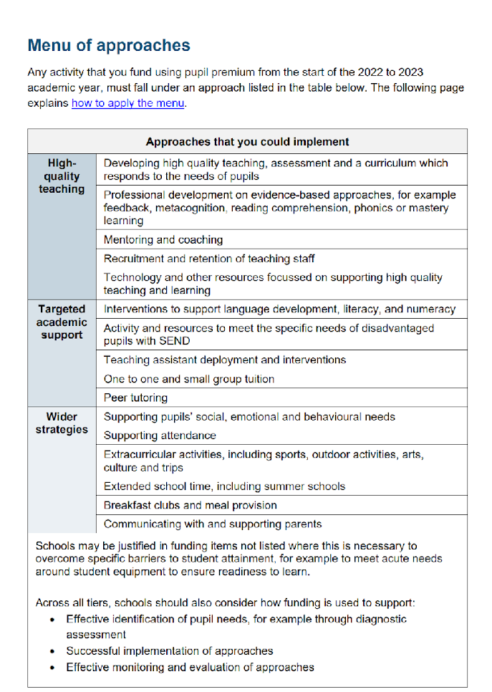
Further information (optional)
Use this space to provide any further information about your pupil premium strategy. For example, about your strategy planning, or other activity that you are implementing to support disadvantaged pupils, that is not dependent on pupil premium or recovery premium funding.

