

Pupil premium strategy statement
Expenditure evaluation
Strategy plan
“I was disadvantaged as a child, yet I had the advantage of being in the company of great teachers.”
(A.P.J. Abdul Khan, 11th President of India)
“Every one of our children is carrying something the world is waiting for – it’s just the world hasn’t got it yet,” Sister Judith Russi
The ‘Pupil Premium’ is a government initiative that provides extra funding aimed at pupils from disadvantaged backgrounds. Research shows that pupils from deprived backgrounds underachieve compared to their peers and that there is a strong link between eligibility for free school meals and underachievement. The Pupil Premium is designed to help each school boost the attainment of disadvantaged children and reduce the gap between the highest and the lowest achievers. The government has used pupils’ entitlement to free school meals (FSM) and children looked after by the local authority (CLA) as an indicator for deprivation. The funding is allocated according to the number of pupils on roll who have been eligible for free school meals at any point in the last 6 years (known as ‘Ever6 FSM’), an allocation for each pupil who has been ‘Looked After’ (in care) and a smaller amount for the children of service families.
Principles
- To ensure that teaching and learning opportunities meet the needs of all pupils.
- To ensure that appropriate provision is made for pupils who belong to vulnerable groups, this includes ensuring that the needs of socially disadvantaged pupils are adequately assessed and addressed.
- In making provision for socially disadvantaged pupils, we recognise that not all pupils who receive free school meals will be socially disadvantaged.
- We also recognise that not all pupils who are socially disadvantaged are registered for free school meals. We reserve the right to allocate the Pupil Premium funding to support any pupil, or groups of pupils the schools have legitimately identified as being socially disadvantaged.
- Pupil Premium funding will be allocated following a needs analysis which will identify priority groups or individuals. Limited funding and resources means that not all children receiving free school meals will be in receipt of pupil premium interventions at one time.

Pupil premium strategy statement

This statement details our school’s use of pupil premium (and recovery premium for the 2022 to 2023 academic year) funding to help improve the attainment of our disadvantaged pupils.

It outlines our pupil premium strategy, how we intend to spend the funding in this academic year and the effect that last year’s spending of pupil premium had within our school.

School overview
Detail | Data
School name | St Margaret Clitherow Catholic Primary School
Number of pupils in school | 58
Proportion (%) of pupil premium eligible pupils | 46.5%
Academic year/years that our current pupil premium strategy plan covers (3 year plans are recommended) | 2025-2028
Date this statement was published | November 15th 2025
Date on which it will be reviewed | February 2026
Statement authorised by | Jo Flower
Pupil premium lead | Hannah Maskell
Governor / Trustee lead | Jane Young
Funding overview
Detail | Amount
Pupil premium funding allocation this academic year | £ 41,495.56
Recovery premium funding allocation this academic year | £ 0
Pupil premium funding carried forward from previous years (enter £0 if not applicable) | £ 0
Total budget for this academic year  If your school is an academy in a trust that pools this funding, state the amount available to your school this academic year | £41,495.56

Part A: Pupil premium strategy plan

Statement of intent
You may want to include information on:
- What are your ultimate objectives for your disadvantaged pupils?
- How does your current pupil premium strategy plan work towards achieving those objectives?
- What are the key principles of your strategy plan?
At St Margaret Clitherow Catholic Primary School, we target the use of Pupil Premium Grant funding to ensure that our disadvantaged pupils receive the highest quality of education to enable them to become active, socially responsible citizens of the future. We recognise that disadvantaged children can face a wide range of barriers which may impact on their learning.
Our ultimate objectives are to:
- Remove barriers to learning created by poverty, family circumstance and background
- Narrow the attainment gaps between disadvantaged pupils and their non-disadvantaged counterparts both within school and nationally
- Ensure ALL pupils are able to read fluently and with good understanding to enable them to access the breadth of the curriculum
- Develop confidence in their ability to communicate effectively in a wide range of
- contexts
- Enable pupils to look after their social and emotional wellbeing and to develop
- resilience.
- Access a wide range of opportunities to develop their knowledge and understanding of the world
Our Context:
- Torbay is the most deprived local authority area in the South West region. Within Torbay, around one-in-three of the population live in areas in the top 20% most deprived in England.
- 32% of pupils are eligible for Pupil Premium Funding in comparison to 23% national.

Achieving our objectives:
In order to achieve our objectives and overcome identified barriers to learning we will:
- Provide all teachers with high quality CPD to ensure that pupils access effective
- quality first teaching
- Provide targeted intervention and support to quickly address identified gaps in
- learning including the use of small group work, 1:1 tuition
- Target funding to ensure that all pupils have access to trips, residentials, first
- hand learning experiences
- Provide opportunities for all pupils to participate in enrichment activities including sport and music
- Provide appropriate nurture support to enable pupils to access learning within
- and beyond the classroom.
3
This is not an exhaustive list and strategies will change and develop based on the needs of individuals.
Key Principals:
We will ensure that effective teaching, learning and assessment meets the needs of all pupils through the rigorous analysis of data. Class teachers will identify through the class pupil premium plan, specific intervention and support for individual pupils which will be reviewed at least termly. Alongside academic support, we will ensure that those pupils who have social, emotional and mental health needs will access high quality provision from appropriately trained adults.

Challenges
This details the key challenges to achievement that we have identified among our disadvantaged pupils.
Challenge number | Detail of challenge
1 | Our assessments, observations and discussions with pupils and families have identified social and emotional issues for many pupils, notably due to a lack of social interaction, enrichment opportunities and difficulties integrating into whole class social situations. These challenges particularly affect disadvantaged pupils, including their attainment.
2 | Our attendance data over the last 3 years indicates that attendance among disadvantaged pupils has been between 1-6 % lower than for non-disadvantaged pupils. Disadvantaged children are often less punctual and many regularly miss out on the start of the day.
3 | Parental engagement Our records and experience shows us that families of our disadvantaged children are less likely to be involved in the school life of their children. Home issues affect engagement with learning and the general wellbeing of the children. Often the wider family need support to ensure success for children attending school.
4 | Speech, language and communication 5 Assessments, observations, and discussions with pupils indicate underdeveloped oral language skills and vocabulary gaps among many disadvantaged pupils. These are evident from Reception through to KS2 and in general, are more prevalent among our disadvantaged pupils than their peers.
5 | Gaps in reading, writing and maths  In 24-25, 11% less achieved ARE in reading, 9% in writing and 15% in maths. On entry to Reception class in the last 3 years, between 50% and 100% of our disadvantaged pupils arrive below age-related expectations compared to 10 - 35% of other pupils. This gap remains steady to the end of KS2. Of all pupils on the PP register, 50% have joined the school within the last 2 years as in year admissions from other school.

Intended outcomes
This explains the outcomes we are aiming for by the end of our current strategy plan, and how we will measure whether they have been achieved.
Intended outcome | Success criteria
To achieve and sustain improved wellbeing for all pupils in our school, particularly our disadvantaged pupils. | - To achieve and sustain improved wellbeing for all pupils in our school, particularly our disadvantaged pupils. Sustained high levels of wellbeing from 2025/26 demonstrated by:  ● qualitative data from student voice, student and parent surveys and teacher observations  ● a significant increase in participation in enrichment activities, particularly among disadvantaged pupils  - ● Trauma informed schools survey related to bonding and evidence that children are feeling a stronger sense of belonging.
To achieve and sustain improved attendance for all pupils, particularly our disadvantaged pupils. | Sustained high attendance from 2025/26 demonstrated by:  ● the overall absence rate for all pupils being no more than 5%, and the attendance gap between disadvantaged pupils and their non-disadvantaged peers being reduced to no gap.  ● the percentage of all pupils who are persistently absent being below 10% and the figure among disadvantaged pupils being no more than 5% lower than their peers.
Improved parental engagement with families reporting they feel well supported. | Outcomes to show that parental engagement is high and this is having a positive impact on the attainment of their children.
Improved attainment for disadvantaged children at the end of KS2 particularly in reading and writing. | Outcomes to show there is no gap and attainment is at least in line with national outcomes for disadvantaged.
Improved oral language skills and vocabulary among disadvantaged pupils. | Assessments and observations indicate significantly improved oral language among disadvantaged pupils. This is evident when triangulated with other sources of evidence, including engagement in lessons, book scrutiny and ongoing formative assessment.

Activity in this academic year
This details how we intend to spend our pupil premium (and recovery premium funding) this academic year to address the challenges listed above.

Teaching (for example, CPD, recruitment and retention)

Activity | Evidence that supports this approach | Challenge number(s) addressed
Purchase Power Maths for all year groups to enable mastery approach | Quality first teaching with a mastery approach is shown to improve outcomes for children through EEF toolkit. | 5  COST: £2365
SENDCo/ SLT support for teachers to secure high impact targets matched to individual needs EEF toolkit has a number of educational research projects that demonstrate the high impact of individualised programmes and targets. | EEF toolkit has a number of educational research projects that demonstrate the high impact of individualised programmes and targets. | 4,5 COST: £6550 (10% HM/LD) SENDCo /SLT time for improving teaching of PP/SEND crossover
Engage services of a family support worker Pupils are safe and are confident in themselves and can manage their emotions effectively. Strengthened partnership with parents/carers. | Strengthened partnership with parents/carers. Parents/Carers regularly support pupils with learning. | 1,2,3 COST (£7910)
Financial support of 75% available to support disadvantaged pupils' access to extracurricular activities and trips. | The opportunity to develop cultural capital without financial barriers, can support personal development and well being. | 3 COST: £4762

Targeted academic support (for example, tutoring, one-to-one support structured interventions)

Activity | Evidence that supports this approach | Challenge number(s) addressed
Targeted interventions for children that have not passed the phonic assessment, or are not fluent readers. | . Phonics has a positive impact overall (+5 months) with very extensive evidence and is an important component in the development of early reading skills, particularly for children from disadvantaged backgrounds. | COST: £4098
Teaching Assistants used as part of the phonics RWI delivery for all EYFS & KS1 children. | This enables more targeted groups to secure better progress EEF toolkit shows that smaller groups, enabling more targeted intervention, secures better progress. | 4 COST: £4786

Wider strategies (for example, related to attendance, behaviour, wellbeing)

Activity | Evidence that supports this approach | Challenge number(s) addressed
Employment of an attendance officer one day per week to work with families to identify and address barriers to attendance and to hold families to account when they fail to attend school regularly. | Evidence from EEF’s Teaching and Learning Toolkit suggests that effective parental engagement can lead to learning gains of +3 months over the course of a year. | 1,2,3  £8000
Contingency fund for acute issues. | Based on our experiences and those of similar schools to ours, we have identified a need to set a small amount of funding aside to respond quickly to needs that have not yet been identified. | All  £3000

Total budgeted cost: £ 41,495

Part B: Review of outcomes in the previous academic year

Pupil premium strategy outcomes
This details the impact that our pupil premium activity had on pupils in the 2021 to 2022 academic year.
Review:

Externally provided programmes
Please include the names of any non-DfE programmes that you purchased in the previous academic year. This will help the Department for Education identify which ones are popular in England
Programme | Provider

Service pupil premium funding (optional)
For schools that receive this funding, you may wish to provide the following information:
Measure | Details
How did you spend your service pupil premium allocation last academic year?
What was the impact of that spending on service pupil premium eligible pupils?

Review Year Two

Externally provided programmes
Please include the names of any non-DfE programmes that you purchased in the previous academic year. This will help the Department for Education identify which ones are popular in England
Programme | Provider

Service pupil premium funding (optional)
For schools that receive this funding, you may wish to provide the following information:
Measure | Details
How did you spend your service pupil premium allocation last academic year?
What was the impact of that spending on service pupil premium eligible pupils?

Review Year Three

Externally provided programmes
Please include the names of any non-DfE programmes that you purchased in the previous academic year. This will help the Department for Education identify which ones are popular in England
Programme | Provider

Service pupil premium funding (optional)
For schools that receive this funding, you may wish to provide the following information:
Measure | Details
How did you spend your service pupil premium allocation last academic year?
What was the impact of that spending on service pupil premium eligible pupils?

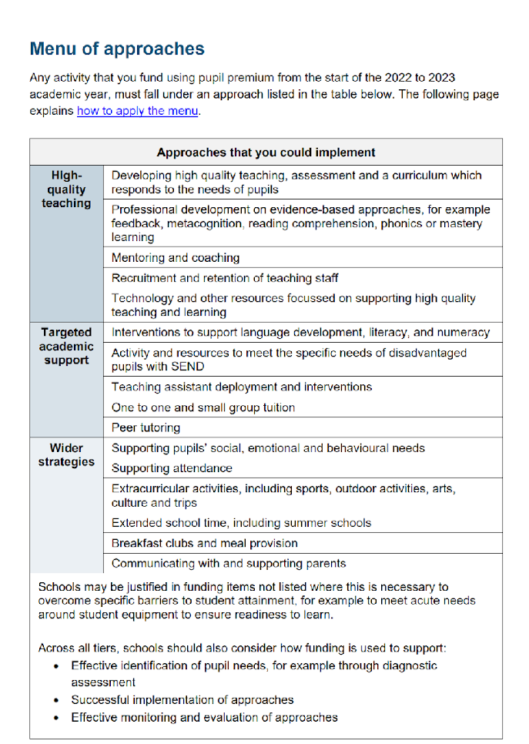
Further information (optional)
Use this space to provide any further information about your pupil premium strategy. For example, about your strategy planning, or other activity that you are implementing to support disadvantaged pupils, that is not dependent on pupil premium or recovery premium funding.

